- Infant car seat: you won’t be able to leave the hospital by car without one
- 5 suits and singlets for baby to wear while you’re in hospital
- A special outfit for the trip home: all in stretchy outfits are easiest
- Nappies and wipes
- Baby blanket: take something warm if the weather is cold
- Socks or booties and mittens
335 Hannan Street
Kalgoorlie WA 6430
Phone: (08) 9021 3988
www.plazamedicalkalgoorlie.com.au

- Hat/Beanie
- Muslin wraps

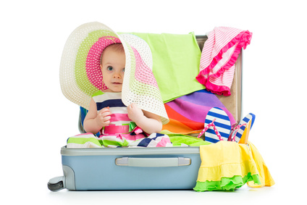

You’re on the home stretch. Now it’s time to prepare for the big day with all the essentials you’ll need for labour and after your baby is born.

Be aware that the hospital can be short on space so you may only have a small cabinet by your bed to store your personal belongings.
You may like to consider packing two bags; one for the labour ward and delivery, and another for your stay on the ward.

- Your pregnancy card and birth plan
- A loose fitting, comfortable nightie or t-shirt to wear in labour, slippers/socks and a lightweight dressing gown
- A change of clothes
- Massage oil or lotion
- Lip balm
- A snack and something to drink
- Something light that may help you to relax and pass the time; books, magazines, card games etc.
- A hair tie
- TENS machine if you chose to use one
- Music to Listen to
- Pen and paper

- Board shorts and an extra shirt
- A plastic bag for wet/soiled items
- Comfortable shoes
- A watch
- Digital camera or video camera
- Mobile phone, charger and contact list to share your news.

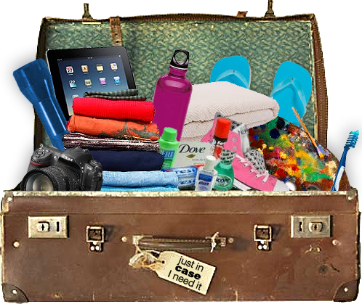

- Comfy maternity clothes. Something that opens in the front is useful in the early days of breastfeeding.
- Comfy bras and undies: 2 or 3 nursing bras or singlets. You may also need more undies than you expect.
- Disposable breast pads.
- Maternity sanitary pads: bring a couple of packs.
- Toiletries: all of those you would normally pack for a holiday (your favourite brand of soap, hair care, toothbrush/toothpaste, moisturiser, deodorant etc.)

